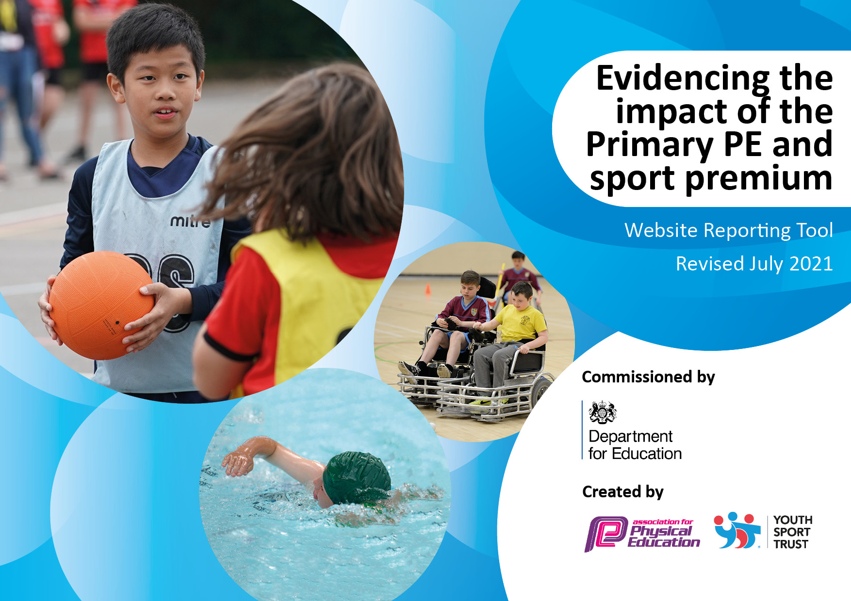
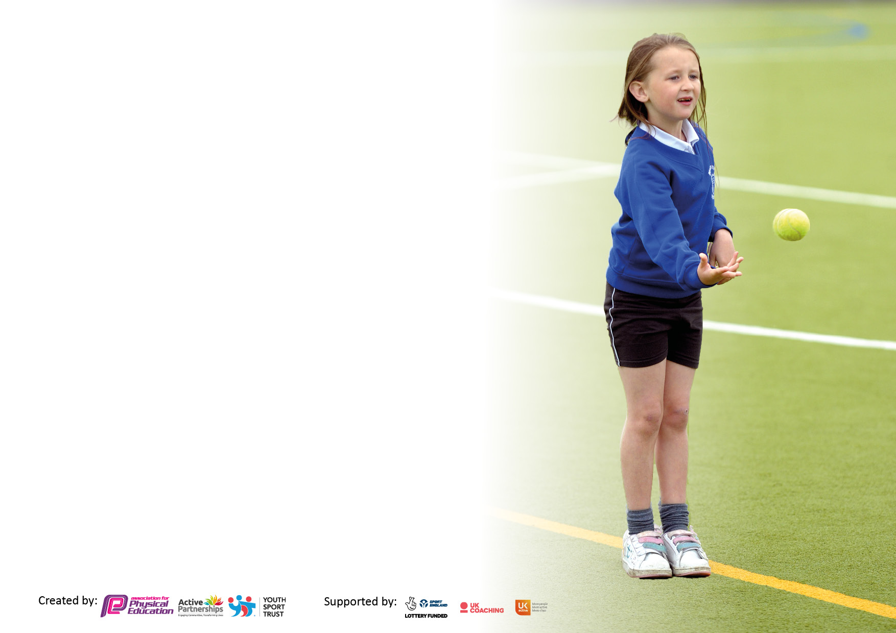

It is important that your grant is used effectively and based on school need. The Education Inspection Framework makes clear there will be a focus on ‘whether leaders and those responsible for governors all understand their respective roles and perform these in a way that enhances the effectiveness of the school’.

Under the Quality of Education Ofsted inspectors consider:
Intent - Curriculum design, coverage and appropriateness
Implementation - Curriculum delivery, Teaching (pedagogy) and Assessment
Impact - Attainment and progress

To assist schools with common transferable language this template has been developed to utilise the same three headings which should make your plans easily transferable between working documents.

Schools must use the funding to make additional and sustainable improvements to the quality of Physical Education, School Sport and Physical Activity (PESSPA) they offer. This means that you should use the Primary PE and sport premium to:

- Develop or add to the PESSPA activities that your school already offer
- Build capacity and capability within the school to ensure that improvements made now will benefit pupils joining the school in future years
- The Primary PE and sport premium should not be used to fund capital spend projects; the school’s budget should fund these.

Pleasevisitgov.ukfortherevisedDfEguidanceincludingthe5keyindicatorsacrosswhichschoolsshoulddemonstrate animprovement.Thisdocumentwillhelpyoutoreviewyourprovisionandtoreportyourspend.DfEencouragesschools to use this template as an effective way of meeting the reporting requirements of the Primary PE and sport premium.

We recommend you start by reflecting on the impact of current provision and reviewing the previous spend.

Schools are required to publish details of how they spend this funding, including any under-spend from 2019/2020, as well as on the impact it has on pupils’ PE and sport participation and attainment. All funding must be spent by 31st July 2022.

We recommend regularly updating the table and publishing it on your website throughout the year. This evidences your ongoing self-evaluation of how you are using the funding to secure maximum, sustainable impact. Final copy must be posted on your website by the end of the academic year and no later than the 31st July 2021. To see an example of how to complete the table please click HERE.

Details with regard to funding
Please complete the table below.

Total amount carried over from 2019/20 | £1,200.00
Total amount allocated for 2020/21 | £17,070.00
How much (if any) do you intend to carry over from this total fund into 2021/22? | £3,160.00
Total amount allocated for 2021/22 | £17,300.00
Total amount of funding for 2021/22. To be spent and reported on by 31st July 2022. | £20,460.00
Swimming Data
Please report on your Swimming Data below.

Meeting national curriculum requirements for swimming and water safety.
N.B. Complete this section to your best ability. For example you might have practised safe self-rescue techniques on dry land which you can then transfer to the pool when school swimming restarts.
Due to exceptional circumstances priority should be given to ensuring that pupils can perform safe self rescue even if they do not fully meet the first two requirements of the NC programme of study
What percentage of your current Year 6 cohort swim competently, confidently and proficiently over a distance of at least 25 metres?  N.B. Even though your pupils may swim in another year please report on their attainment on leaving primary school at the end of the summer term 2020.  Please see note above | 84% (16/19 pupils)
What percentage of your current Year 6 cohort use a range of strokes effectively [for example, front crawl, backstroke and breaststroke]?  Please see note above | 84% (16/19 pupils)
What percentage of your current Year 6 cohort perform safe self-rescue in different water-based situations? | 78% (15/19 pupils)
Schools can choose to use the Primary PE and sport premium to provide additional provision for swimming but this must be for activity over and above the national curriculum requirements. Have you used it in this way? | No

Action Plan and Budget Tracking
Capture your intended annual spend against the 5 key indicators. Clarify the success criteria and evidence of impact that you intend to measure to evaluate for pupils today and for the future.

Academic Year: 2020/21 | Total fund allocated: £ 17,070.00 | Date Updated: July 2021
Key indicator 1: The engagement of all pupils in regular physical activity – Chief Medical Officers guidelines recommend that primary school pupils undertake at least 30 minutes of physical activity a day in school |  |  |  | Percentage of total allocation:
 |  |  |  | 13%
Intent | Implementation |  | Impact
Your school focus should be clear what you want the pupils to know and be able to do and about  what they need to learn and to  consolidate through practice: | Make sure your actions to achieve are linked to your intentions: | Funding allocated: | Evidence of impact: what do pupils now know and what can they now do? What has changed?: | Sustainability and suggested next steps:
Engage all EYFS and KS1 pupils in regular sporting opportunities at breaktimes and lunchtimes to initiate an early interest in physical activity. | Provide a range of high-quality, engaging coach-led sport lunch time activities for EYFS and KS1 bubbles twice a week.  Ensure sessions are appropriately resourced. | £2,240.00 | The use of a high quality external sports’ coach has allowed pupils to build a trusting relationship with a sporting role-model. EYFS and KS1 pupils are excited for the delivery of the sessions. All EYFS pupils have had the opportunity to take part in many types of sports, such as hockey, football, tennis and archery, as well as being led through exciting physical challenges and games.  The coaches have also provided observation sessions for our MSAs, encouraging and building their confidence to deliver their own physical sessions at lunchtime. | Continue with providing high-quality, engaging coach-led sporting and physical activity lunchtime sessions twice a week in the Autumn term 2021.  Re-establish lunchtime and after school sporting clubs from Autumn 2021 without the need for bubbles.  Discuss with MSA about delivering further sports and activity clubs, providing CPD to support them with this.  Investigate further hardy, weather-proof outdoor active play equipment for use at playtimes and lunchtimes.
Key indicator 2: The profile of PESSPA being raised across the school as a tool for whole school improvement |  |  |  | Percentage of total allocation:
 |  |  |  | 17%
Intent | Implementation |  | Impact
Your school focus should be clear what you want the pupils to know and be able to do and about  what they need to learn and to  consolidate through practice: | Make sure your actions to achieve are linked to your intentions: | Funding allocated: | Evidence of impact: what do pupils now know and what can they now do? What has changed?: | Sustainability and suggested next steps:
Ensure pupils increase mental and physical fitness levels in KS1 and KS2 by providing 3 hours of PE lessons a week. Lockdown prevented many of our pupils from living a fit and healthy lifestyle. It was clear that this had a negative effect on their well-being, ability to sustain concentration in learning and overall confidence. There was also a negative impact on pupils’ social stamina, including their ability to work within a team. | Support teaching staff in providing an additional coach to enhance physical activity opportunities for pupils in PE sessions. | £2,830.00 | An additional hour of PE lessons a week in the summer term allowed pupils to work not only on their physical ability, but also increased a number of other positive elements. This time allowed pupils to build on their confidence and relearn how to work effectively together in teams.  Staff and coaches worked together to deliver highly engaging PE sessions at least once a week for an hour. The coach allowed teachers to further adapt PE teaching by taking additional groups of pupils who needed extending or additional support due to physical needs.  Teachers reported that pupils’ behaviour had improved and their stamina and confidence in other lessons had also increased. | Prioritise the delivery of indoor/ sports hall sports and activity in Autumn 2021, including dance and gymnastics to allow pupils to develop knowledge and skills lost due to lockdown and use of class bubbles.  Continue to allow pupils to come to school wearing PE kits on the days that they have PE to maximise physical activity in lessons.  Monitor use of physical activity in lessons to promote active learning. Provide resources and CPD to enhance opportunities.  Investigate the possibility of outdoor active learning equipment to support EYFS and KS1.

Key indicator 3: Increased confidence, knowledge and skills of all staff in teaching PE and sport |  |  |  | Percentage of total allocation:
 |  |  |  | 19%
Intent | Implementation |  | Impact
Your school focus should be clear | Make sure your actions to | Funding | Evidence of impact: what do | Sustainability and suggested
what you want the pupils to know | achieve are linked to your | allocated: | pupils now know and what | next steps:
and be able to do and about | intentions: |  | can they now do? What has
what they need to learn and to |  |  | changed?:
consolidate through practice:
Provide high quality CPD for all teachers in the delivery of PE, particularly in outdoor games and ensure resourcing is effective to deliver this. | Use partnership with Premier Sports to deliver upskilling sessions to all teachers in the school in PE lessons. Multisports delivery was a priority for EYFS and KS1 classes and cricket KS2.  Complete PE equipment audit and purchase resources to deliver high quality, engaging multisports and cricket sessions.  Provide CPD for all staff through the virtual Hertfordshire PE Conference 2021. | £2,830.00  £130.00  £300 | Through informal lesson drop-ins and conversations with staff, it was clear that all staff felt the CPD was very useful. Many delivered CPD activities were adapted and used in further sessions to progress children’s knowledge and skills further. Staff had enough equipment to confidently ensure all pupils were engaged and participating at an appropriate level for their age and skill level.  Having the Hertfordshire PE conference virtual this year allowed teaching staff to watch sessions which were appropriate to their needs. Staff engaged in sessions regarding warm-ups, well-being and leadership. | Complete updated audit on staff regarding their confidence, knowledge and skills in PE to prioritise and organise further CPD in 2021/22, particularly for new staff.  Ensure resourcing is adequate for PE, particularly in dance and gymnastics which will be prioritised in 2021/22.  Investigate the Hertfordshire PE conference 2022 and explore ways to deliver sessions to appropriate staff.  Investigate using the partnership with NHSSP to deliver advice and further CPD.
Key indicator 4: Broader experience of a range of sports and activities offered to all pupils |  |  |  | Percentage of total allocation:
 |  |  |  | 17%
Intent | Implementation |  | Impact
Your school focus should be clear | Make sure your actions to | Funding | Evidence of impact: what do | Sustainability and suggested
what you want the pupils to know | achieve are linked to your | allocated: | pupils now know and what | next steps:
and be able to do and about | intentions: |  | can they now do? What has
what they need to learn and to |  |  | changed?:
consolidate through practice:
Deliver a Road to Tokyo Olympics and Paralympic enrichment project to all classes in the school to encouraging children to lead active lives and embrace the core values of friendship, respect, excellence, determination, inspiration, courage and equality.  Ensure pupils have access to activity and sport clubs based on their pupil voice views. | Link to partnership with Premier Sports to deliver this enrichment project alongside further support for classes and CPD for teachers.  Two after school sports’ sessions were arranged. KS2 pupils were asked which clubs they would like to attend through the year. They shared interest in athletics and hockey. | £2,830.00 | All pupils in all classes took part in a 6 week enrichment project based around the core values of the Olympics and Paralympics, suitable for the different age ranges in the school.  Pupils engaged in a number of different sports including archery, hockey, gymnastics and athletics. These sessions supported pupils’ reintegration into school life after lockdown and reinstated important school values alongside the passion of the Olympics.  The uptake of afterschool sports had increased from 8 pupils in the Autumn term, to 17 pupils in the summer term. The feedback from pupils was positive and all pupils who attended these clubs in the first part of the summer term, continued into the second part of the summer term. | Arrange new date for the Paralympic Roadshow through the Herts Disability Sports Foundation in 2021/2022.  Make further enrichment opportunities available for pupils for the Winter Olympics and Paralympics in 2022/ Commonwealth games 2022. Investigate possible resources to support this.  Investigate further interest for sports clubs through pupil voice/ questionnaire in 2021/22. Ensure opportunities are available to KS1 pupils. Dodgeball will be reinstated due to a keen interest in 2020/21. Gymnastics to also be offered as a means to improve children’s knowledge and skills after indoor sports being postponed in the pandemic.

Key indicator 5: Increased participation in competitive sport |  |  |  | Percentage of total allocation:
 |  |  |  | 16%
Intent | Implementation |  | Impact
Your school focus should be clear | Make sure your actions to | Funding | Evidence of impact: what do | Sustainability and suggested
what you want the pupils to know | achieve are linked to your | allocated: | pupils now know and what | next steps:
and be able to do and about | intentions: |  | can they now do? What has
what they need to learn and to |  |  | changed?:
consolidate through practice:
Ensure pupils have regular opportunities to compete in competitive sport activities, including festivals, throughout 2021/22, alongside high quality CPD and advice for staff. | Continue Gold membership with North Herts School Sports Partnership in 2021/22. | £2750 | Throughout lockdown, Pirton School continued to suggest NHSSP activity and competition ideas to pupils through home learning and with key worker pupils in school.  We have decided for 2021/22 to increase the package provided from the NHSSP from Silver to Gold, in order to enhance the competition and CPD opportunities available to our pupils and staff. | Due to the impact the pandemic had on Pirton School, increased participation in competitive sport was not a priority for Pirton School in 2020/2021. However, this will become one of our main priorities in 2021/22.  Through our partnership with NHSSP and further inter and intra school connections, we hope to provide a rich diet of festival and competitive events to as many pupils as possible through KS1 and KS2.

2019-20 Carry Over Funding Report

Academic Year: September 2020 to March 2021 | Total fund carried over: £  Underspend: £1,200 | Date Updated:  Mar 2021
What Key indicator(s) are you going to focus on?  Key indicator 1: The engagement of all pupils in regular physical activity – Chief Medical Officer guidelines recommend that primary school pupils undertake at least 30 minutes of physical activity a day in school  Key indicator 3: Increased confidence, knowledge and skills of all staff in teaching PE and sport |  |  |  | Total Carry Over Funding:
 |  |  |  | £1200.00
Intent | Implementation |  | Impact
Your school focus should be clear how you want to impact on your pupils.  ‘£1200 from 2019/2020 PE and Sport Premium Possible spend: Ensure adequate resources are available to support social distancing measures and active time in ‘bubbles’ from September. Resources to include equipment can be used individually by children.’ (Taken from Pirton School’s PE and Sports’ Premium reporting document 2019-2020)  As pupils returned in the Autumn term 2020, it was clear teaching staff were feeling a heightened sense of anxiety towards teaching PE safely. We also knew that many pupils had been less active for much of the previous summer term due to school closures. We made plans to ensure that we had enough equipment to deliver PE lessons where pupils did not need to share or pass equipment between class bubbles. We also wanted to ensure that staff had high quality support in place through PE lesson planning and sequencing which supported our social distancing measures and prioritised outdoor sports. | Make sure your actions to achieve are linked to your intentions:  Complete PE Resource Annual licence (including social distancing planning support)  Outdoor Education CAAPS (Outdoor and Adventurous activity resource)  PE lesson/ Sports equipment | Carry over funding allocated:  £105.00  £79.00  £1016.00 | Evidence of impact: How can you measure the impact on your pupils; you may have focussed on the difference that PE, SS & PA have made to pupils re-engagement with school. What has changed?:  All pupils were able to access two hours of high quality PE lessons a week, with social distancing measures in place. The PE long term plan was adapted to ensure equipment was not being shared across class bubbles and that pupils had individual use of resources where appropriate. Strict cleaning procedures were also in place to ensure equipment was safe for pupils to use. Additional high quality social distancing PE schemes of learning supported pupils in being active in PE lesson, whilst remaining safe. These measures also supported staff in feeling less anxious towards teaching PE safely. | Sustainability and suggested next steps and how does this link with the key indicators on which you are focussing this academic year?:  Sustainability:  New PE equipment provides opportunities for future cohorts.  Opportunities for outdoor PE embedded into future planning.  Next steps:  Subject leader to prioritise indoor PE and swimming units in future long term planning, when safe to do so, in order to ensure pupils receive their full entitlement to the PE curriculum. Teaching staff to assess pupils’ knowledge and skills and build opportunities to close any gaps into their PE lesson planning and throughout the curriculum.

Signed off by
Head Teacher: | Sonia Fenner
Date: | 27.07.21
Subject Leader: | Samantha McDonald
Date: | 27.07.21
Governor: | Bharathi Brown
Date: | 27.07.21

