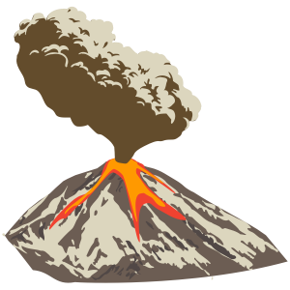
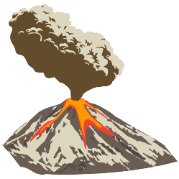
Owls’ Summer Topic Homework Mat: Extreme Earth

Please use the ideas below to explore our topic. You can record any home learning in your homework book. Complete at least three tasks before Monday 4th July 2022. Feel free to bring your home learning to school when you are ready.

Create a geography dictionary based on 10 words related to this topic. | Research extreme weather that interests you, present the information as a PowerPoint presentation or a leaflet. | Create an advice leaflet outlining what to do should a volcano erupt. | Write an acrostic poem using the letters from the word ‘VOLCANO’.
Look at the clouds. Can you take a photograph or draw and describe the clouds you see? Can you use the internet to identify the clouds you have seen? Record on poster paper to share with the class. | Create your own biome. Draw and label a diagram of your biome. Make sure you show or describe the climate, vegetation and animals in your biome. | Write an interview between a journalist and an emergency aid worker. Include what the aid worker does if there is a natural disaster and why they do it. | Research and write a report on the volcanos that are currently active in the world. Include the countries that they are found in, how the local people live and are affected by the volcano. Can you find out how the volcanoes effect the landscape?
Write an explanation text about the Richter scale. | Write a newspaper report based on a natural disaster that has happened within the past ten years. | Create a word search or crossword using words and facts from this topic. | If you have any other ideas how to explore this topic further, feel free to be as creative as you wish.

