Homework Grid – Summer Term

Art  Practice drawing people. Focus on all body parts. | PHSE  Think about what makes a good friend. Can you create good friend recipe.  A pinch of laughter.  A spoonful of patience. | Science – Magnets  Will it stick?  Make a collection of household objects and test them with a magnet. Which materials stick? Which did not? Can you name the different types of magnetic materials?
Maths  Work on telling the time o’clock, quarter past, quarter to and then 5-minute intervals.  Challenge yourself to 24 hour clock! | Summer Term  Homework Grid for Swifts  Please complete at least 3 of these activities over the term. | History – Ancient Egyptians  Design your own Death Mask  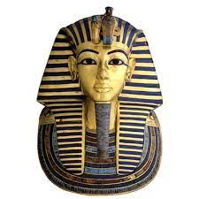
Geography  Create your own treasure map. (You could do this with an old tea bag to make it look old). Give directions using compass points to find your treasure. |  | Geography  Design your own navigation compass
Art / DT  Use a balloon to make your own pneumatic toy at home. |  | English  Become an author. Create a story that includes a clear beginning, middle and end.  Be creative with your language!
History – Ancient Egyptians  Write your name using hieroglyphics. You could turn this into a bookmark or a door sign for your room. | Science – Forces  Use the words push and pull to describe every action you do for an hour. Record these down. For example: I pushed the door open. I pulled my t-shirt over my head.  Forces are everywhere! | Art  Make a collage out of materials found in nature. Take a photo.

